ANDRIOD LAB EXAM

K.SHRIVARSHINI

CH.EN.U4CYS21077

CYS-B

Question-3

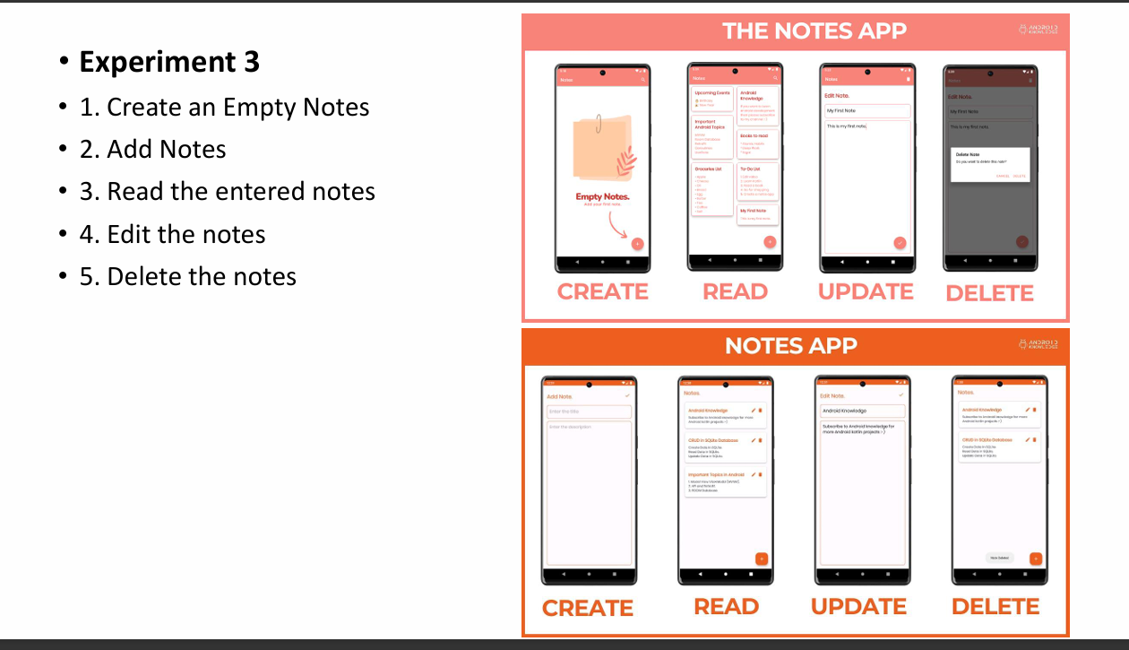

CODE FILES

Activity_main.xml

<?xml version="1.0" encoding="utf-8"?>  
<LinearLayout xmlns:android="http://schemas.android.com/apk/res/android"  
 android:layout_width="match_parent"  
 android:layout_height="match_parent"  
 android:orientation="vertical"

MainActivity.java  
  
  
package com.example.labexam;  
  
import android.content.Intent;  
import android.os.Bundle;  
import android.view.View;  
import android.widget.Button;  
  
import androidx.appcompat.app.AppCompatActivity;  
  
public class MainActivity extends AppCompatActivity {  
  
 private Button addNoteButton, viewNotesButton;  
  
 @Override  
 protected void onCreate(Bundle savedInstanceState) {  
 super.onCreate(savedInstanceState);  
 setContentView(R.layout.*activity_main*);  
  
 addNoteButton = findViewById(R.id.*add_note_button*);  
 viewNotesButton = findViewById(R.id.*view_notes_button*);  
  
 addNoteButton.setOnClickListener(new View.OnClickListener() {  
 @Override  
 public void onClick(View v) {  
 Intent intent = new Intent(MainActivity.this, AddEditNoteActivity.class);  
 startActivity(intent);  
 }  
 });  
  
 viewNotesButton.setOnClickListener(new View.OnClickListener() {  
 @Override  
 public void onClick(View v) {  
 Intent intent = new Intent(MainActivity.this, ViewNotesActivity.class);  
 startActivity(intent);  
 }  
 });  
 }  
}

AddEditNoteActivity.java

package com.example.labexam;  
  
import android.content.Intent;  
import android.os.Bundle;  
import android.view.View;  
import android.widget.EditText;  
import android.widget.Toast;  
  
import com.google.android.material.floatingactionbutton.FloatingActionButton;  
import androidx.appcompat.app.AppCompatActivity;  
  
public class AddEditNoteActivity extends AppCompatActivity {  
 EditText noteTitle, noteContent;  
 FloatingActionButton saveNoteButton, deleteNoteButton;  
  
 private DatabaseHelper databaseHelper;  
 private int noteId = -1; // -1 means a new note  
  
 @Override  
 protected void onCreate(Bundle savedInstanceState) {  
 super.onCreate(savedInstanceState);  
 setContentView(R.layout.*activity_add_edit_note*);  
  
 noteTitle = findViewById(R.id.*note_title*);  
 noteContent = findViewById(R.id.*note_content*);  
 saveNoteButton = findViewById(R.id.*save_note_button*);  
 deleteNoteButton = findViewById(R.id.*delete_note_button*);  
  
 databaseHelper = new DatabaseHelper(this);  
  
 // Check if editing an existing note  
 Intent intent = getIntent();  
 if (intent.hasExtra("NOTE_ID")) {  
 noteId = intent.getIntExtra("NOTE_ID", -1);  
 Note note = databaseHelper.getNoteById(noteId);  
 if (note != null) {  
 noteTitle.setText(note.getTitle());  
 noteContent.setText(note.getContent());  
 deleteNoteButton.setVisibility(View.*VISIBLE*); // Show delete button  
 }  
 }  
  
 saveNoteButton.setOnClickListener(new View.OnClickListener() {  
 @Override  
 public void onClick(View v) {  
 String title = noteTitle.getText().toString();  
 String content = noteContent.getText().toString();  
  
 if (noteId == -1) {  
 // Create new note  
 databaseHelper.insertNote(new Note(title, content));  
 Toast.*makeText*(AddEditNoteActivity.this, "Note added", Toast.*LENGTH_SHORT*).show();  
 } else {  
 // Update existing note  
 databaseHelper.updateNote(new Note(noteId, title, content));  
 Toast.*makeText*(AddEditNoteActivity.this, "Note updated", Toast.*LENGTH_SHORT*).show();  
 }  
  
 finish(); // Close activity and return to previous one  
 }  
 });  
  
 deleteNoteButton.setOnClickListener(new View.OnClickListener() {  
 @Override  
 public void onClick(View v) {  
 if (noteId != -1) {  
 databaseHelper.deleteNote(noteId);  
 Toast.*makeText*(AddEditNoteActivity.this, "Note deleted", Toast.*LENGTH_SHORT*).show();  
 finish(); // Close activity  
 }  
 }  
 });  
 }  
}

ViewNotesActivity.java

package com.example.labexam;  
  
import android.content.Intent;  
import android.os.Bundle;  
import android.view.View;  
import android.widget.AdapterView;  
import android.widget.ArrayAdapter;  
import android.widget.ListView;  
  
import androidx.appcompat.app.AppCompatActivity;  
  
import java.util.List;  
  
public class ViewNotesActivity extends AppCompatActivity {  
 private ListView notesListView;  
 private DatabaseHelper databaseHelper;  
  
 @Override  
 protected void onCreate(Bundle savedInstanceState) {  
 super.onCreate(savedInstanceState);  
 setContentView(R.layout.*activity_view_notes*);  
  
 notesListView = findViewById(R.id.*notes_list_view*);  
 databaseHelper = new DatabaseHelper(this);  
  
 loadNotes();  
 }  
  
 private void loadNotes() {  
 List<Note> noteList = databaseHelper.getAllNotes();  
 ArrayAdapter<Note> adapter = new ArrayAdapter<>(this, android.R.layout.*simple_list_item_1*, noteList);  
 notesListView.setAdapter(adapter);  
  
 // Set an item click listener to edit a note  
 notesListView.setOnItemClickListener(new AdapterView.OnItemClickListener() {  
 @Override  
 public void onItemClick(AdapterView<?> parent, View view, int position, long id) {  
 Note note = (Note) parent.getItemAtPosition(position);  
 Intent intent = new Intent(ViewNotesActivity.this, AddEditNoteActivity.class);  
 intent.putExtra("NOTE_ID", note.getId());  
 startActivity(intent);  
 }  
 });  
 }  
}

DatabaseHelper.java

package com.example.labexam;  
  
import android.content.ContentValues;  
import android.content.Context;  
import android.database.Cursor;  
import android.database.sqlite.SQLiteDatabase;  
import android.database.sqlite.SQLiteOpenHelper;  
  
import java.util.ArrayList;  
import java.util.List;  
  
public class DatabaseHelper extends SQLiteOpenHelper {  
  
 private static final String *DATABASE_NAME* = "notes.db";  
 private static final int *DATABASE_VERSION* = 1;  
 private static final String *TABLE_NOTES* = "notes";  
  
 private static final String *COLUMN_ID* = "id";  
 private static final String *COLUMN_TITLE* = "title";  
 private static final String *COLUMN_CONTENT* = "content";  
  
 public DatabaseHelper(Context context) {  
 super(context, *DATABASE_NAME*, null, *DATABASE_VERSION*);  
 }  
  
 @Override  
 public void onCreate(SQLiteDatabase db) {  
 String createTable = "CREATE TABLE " + *TABLE_NOTES* + " (" +  
 *COLUMN_ID* + " INTEGER PRIMARY KEY AUTOINCREMENT, " +  
 *COLUMN_TITLE* + " TEXT NOT NULL, " +  
 *COLUMN_CONTENT* + " TEXT NOT NULL)";  
 db.execSQL(createTable);  
 }  
  
 @Override  
 public void onUpgrade(SQLiteDatabase db, int oldVersion, int newVersion) {  
 db.execSQL("DROP TABLE IF EXISTS " + *TABLE_NOTES*);  
 onCreate(db);  
 }  
  
 public void insertNote(Note note) {  
 SQLiteDatabase db = this.getWritableDatabase();  
 ContentValues values = new ContentValues();  
 values.put(*COLUMN_TITLE*, note.getTitle());  
 values.put(*COLUMN_CONTENT*, note.getContent());  
  
 db.insert(*TABLE_NOTES*, null, values);  
 db.close();  
 }  
  
 public Note getNoteById(int id) {  
 SQLiteDatabase db = this.getReadableDatabase();  
 Cursor cursor = db.query(*TABLE_NOTES*, new String[]{*COLUMN_ID*, *COLUMN_TITLE*, *COLUMN_CONTENT*},  
 *COLUMN_ID* + "=?", new String[]{String.*valueOf*(id)}, null, null, null, null);  
 if (cursor != null && cursor.moveToFirst()) {  
 Note note = new Note(  
 cursor.getInt(cursor.getColumnIndex(*COLUMN_ID*)),  
 cursor.getString(cursor.getColumnIndex(*COLUMN_TITLE*)),  
 cursor.getString(cursor.getColumnIndex(*COLUMN_CONTENT*))  
 );  
 cursor.close();  
 return note;  
 }  
 return null;  
 }  
  
 public void updateNote(Note note) {  
 SQLiteDatabase db = this.getWritableDatabase();  
 ContentValues values = new ContentValues();  
 values.put(*COLUMN_TITLE*, note.getTitle());  
 values.put(*COLUMN_CONTENT*, note.getContent());  
  
 db.update(*TABLE_NOTES*, values, *COLUMN_ID* + "=?", new String[]{String.*valueOf*(note.getId())});  
 db.close();  
 }  
  
 public void deleteNote(int id) {  
 SQLiteDatabase db = this.getWritableDatabase();  
 db.delete(*TABLE_NOTES*, *COLUMN_ID* + "=?", new String[]{String.*valueOf*(id)});  
 db.close();  
 }  
  
 public List<Note> getAllNotes() {  
 List<Note> noteList = new ArrayList<>();  
 String selectQuery = "SELECT * FROM " + *TABLE_NOTES*;  
 SQLiteDatabase db = this.getReadableDatabase();  
 Cursor cursor = db.rawQuery(selectQuery, null);  
  
 if (cursor.moveToFirst()) {  
 do {  
 Note note = new Note(  
 cursor.getInt(cursor.getColumnIndex(*COLUMN_ID*)),  
 cursor.getString(cursor.getColumnIndex(*COLUMN_TITLE*)),  
 cursor.getString(cursor.getColumnIndex(*COLUMN_CONTENT*))  
 );  
 noteList.add(note);  
 } while (cursor.moveToNext());  
 }  
 cursor.close();  
 return noteList;  
 }  
}

gradient_background.xml

<?xml version="1.0" encoding="utf-8"?>  
<layer-list xmlns:android="http://schemas.android.com/apk/res/android">  
 <item>  
 <shape android:shape="rectangle">  
 <gradient  
 android:startColor="#BA68C8"  
 android:endColor="#4A148C"  
 android:angle="45"/>  
 </shape>  
 </item>  
</layer-list>

Activity_add_edit_note.xml

<?xml version="1.0" encoding="utf-8"?>  
<RelativeLayout xmlns:android="http://schemas.android.com/apk/res/android"  
 android:layout_width="match_parent"  
 android:layout_height="match_parent"  
 android:background="@drawable/gradient_background">  
  
 <!-- App Logo -->  
 <ImageView  
 android:id="@+id/app_logo"  
 android:layout_width="64dp"  
 android:layout_height="64dp"  
 android:layout_alignParentEnd="true"  
 android:layout_margin="16dp"  
 android:src="@mipmap/ic_launcher" /> <!-- Replace with your app logo resource -->  
  
 <EditText  
 android:id="@+id/note_title"  
 android:layout_width="match_parent"  
 android:layout_height="wrap_content"  
 android:hint="Enter Note Title"  
 android:layout_margin="16dp"  
 android:padding="12dp"  
 />  
  
 <EditText  
 android:id="@+id/note_content"  
 android:layout_width="match_parent"  
 android:layout_height="wrap_content"  
 android:hint="Enter Note Content"  
 android:layout_below="@id/note_title"  
 android:layout_margin="16dp"  
 android:padding="12dp"  
 />  
  
 <Button  
 android:id="@+id/save_note_button"  
 android:layout_width="wrap_content"  
 android:layout_height="wrap_content"  
 android:text="Save"  
 android:layout_alignParentBottom="true"  
 android:layout_alignParentEnd="true"  
 android:layout_margin="16dp"  
 android:backgroundTint="#4CAF50"  
 android:textColor="#FFFFFF"  
 android:padding="16dp"  
 android:elevation="6dp"/>  
  
 <Button  
 android:id="@+id/delete_note_button"  
 android:layout_width="wrap_content"  
 android:layout_height="wrap_content"  
 android:text="Delete"  
 android:layout_alignParentBottom="true"  
 android:layout_toStartOf="@id/save_note_button"  
 android:layout_marginEnd="16dp"  
 android:backgroundTint="#F44336"  
 android:textColor="#FFFFFF"  
 android:padding="16dp"  
 android:elevation="6dp"/>  
</RelativeLayout>

Activity_view_notes.xml

<?xml version="1.0" encoding="utf-8"?>  
<RelativeLayout xmlns:android="http://schemas.android.com/apk/res/android"  
 android:layout_width="match_parent"  
 android:layout_height="match_parent"  
 android:background="@drawable/gradient_background">  
  
 <ListView  
 android:id="@+id/notes_list_view"  
 android:layout_width="match_parent"  
 android:layout_height="match_parent"/>  
</RelativeLayout>

SCREENSHOTS:

